VISVESVARAYA TECHNOLOGICAL UNIVERSITY
Jnana Sangama, Machhe, Belagavi, Karnataka 590018

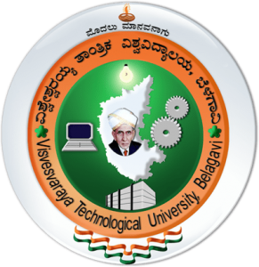

INTERNSHIP-I REPORT
On
“C++ PROGRAMMING AND WEB TECHNOLOGY”

Submitted in partial fulfillment of the requirement
for the award of the degree of

Bachelor of Engineering

In

Information Science and Engineering

By

KRITI P DESAI 1BG25IS029
TANMAYI KT 1BG25IS058
TEJAS GOWDA M 1BG25IS059



An Autonomous Institution under VTU, Approved by AICTE

Department of Information Science and Engineering

2026 – 2027
B.N.M. Institute of Technology
An Autonomous Institution under VTU, Approved by AICTE

DEPARTMENT OF INFORMATION SCIENCE & ENGINEERING

CERTIFICATE

Certified that KRITI P DESAI (1BG25IS029) TANMAYI KT (1BG25IS058) TEJAS GOWDA M (1BG25IS059) has carried out the Internship I – 25ISE146 on C++ Programming and Web Technology conducted internally from 03rd 2026 to 20th August 2026. Candidate has fulfilled all the requirements prescribed in the curriculum. Candidate has incorporated all the corrections/suggestions indicated during the Internal Assessment. The Internship I – 25ISE146 work has been approved as it satisfies the curriculum requirements.

GUIDE

Dr. Laxmi V Dr. S Srividhya Dr. S Y Kulkarni

PROFESSOR Professor & Head, Additional Director &Principal

Dept. of ISE, BNMIT Dept. of ISE, BNMIT BNMIT

B.N.M. Institute of Technology
An Autonomous Institution under VTU, Approved by AICTE

DEPARTMENT OF INFORMATION SCIENCE & ENGINEERING

DECLARATION

KRITI P DESAI (1BG25IS029) TANMAYI KT (1BG25IS058) TEJAS GOWDA M (1BG25IS059) a student of B.E. in Information Science and Engineering, Bengaluru, hereby declare that, I have carried out 15 days of Internship I – 25ISE146 at BNM Institute of Technology, Post Box No.7087, 27th Cross, 12th Main, Banashankari 2nd Stage, Bengaluru-560070 From 21st July 2025 to 7th August 2025 under the guidance of Dr. Laxmi V, PROFESSOR, Department of ISE, BNMIT. This Internship I – 25ISE146 report is submitted to Visvesvaraya Technological University, Belagavi in partial fulfillment of the requirement for the award of degree of Bachelor of Engineering in Information Science & Engineering during the academic year 2026-27.

Place: Bengaluru Signature of Student

Kriti P Desai _________________

Tanmayi KT __________________

Tejas Gowda M _______________

ACKNOWLEDGEMENT

I consider it a privilege to express through the pages of this report, a few words of gratitude to all those distinguished personalities who guided and inspired me in the completion of this Internship-I – 25ISE146.

I would like to thank Shri. Narayan Rao R Maanay, Chairman, BNMEI, Bengaluru for providing an excellent academic environment in college.

I would like to thank Prof. T.J. Rama Murthy, Director, BNMIT, Bengaluru for having extended his support and encouragement during the course of work.

I would like to thank Dr. S.Y. Kulkarni, Additional Director & Principal, BNMIT, Bengaluru for his extended support and encouragement during the course of work.

I would like to express my gratitude to Prof. Eishwar N Maanay, Dean, BNMIT, Bengaluru for his relentless support, guidance, and encouragement.

I would like to thank Dr. Krishnamurthy G.N., Deputy Director, BNMIT, Bengaluru for his constant encouragement.

I would like to thank Dr. S. Srividhya, Professor and Head of the Department of Information Science and Engineering, BNMIT, Bengaluru, for her support and encouragement towards the completion of our Internship-I – 25ISE146.

I would like to thank our Internship-I – 25ISE146 Coordinator GUIDE NAME, DESIGNATION Department of Information Science and Engineering, BNMIT, for being the guiding force towards the successful completion of our Internship-I – 25ISE146.

KRITI P DESAI (1BG25IS029)
TANMAYI KT (1BG25IS058)
TEJAS GOWDA M (1BG25IS059)

ABOUT THE DEPARTMENT

The Department of Information Science & Engineering was established in the year 2001 with an intake of 60. The department has qualified and dedicated faculty members to provide quality education to students. The department is accredited by NBA for the academic year 2024-25 to 2027-28. The department has well-established R & D Centre recognized by VTU, Belagavi, and faculty are actively involved in the research activities, publishing their work in various Journals and Conferences in thrust areas like Network Security, Internet of Things, Computer Vision, Machine Learning, Artificial Intelligence, Image Processing and Deep Learning etc. The department has student projects funded by IEDC. The Department has organized three online and one offline FDPs on thrust areas funded by AICTE Training and Learning Academy (ATAL). The department has state-of-the-art infrastructure to support research and develop students into professionals. Students are trained with multi-dimensional skill sets for their holistic growth. The department regularly organizes skill development programs, internships, workshops, alumni series, hackathon, technical talks and industrial visits to keep the students abreast with technology

ABSTRACT

Manual preparation of academic timetables is a time-consuming and error-prone process that must simultaneously satisfy a large number of competing constraints — faculty availability, room capacity, subject-hour allocation, batch clashes, and laboratory sessions. The Smart Timetable Possibility & Optimization Engine is a software system designed to automate this process by modelling timetable generation as a constraint satisfaction and optimization problem. The system accepts structured institutional data such as courses, faculty, rooms, batches and time slots, and generates one or more feasible, conflict-free timetables that are ranked according to an optimization score.
The engine is built around a rule-based constraint layer that enforces hard constraints — no two classes for the same faculty, room, or batch may overlap — and a scoring layer that evaluates soft constraints such as minimizing idle gaps for faculty, balancing daily workload, and respecting preferred time slots. Candidate timetables are produced using a hybrid approach that combines backtracking search with a genetic algorithm, allowing the system to explore the very large search space efficiently and converge on high-quality solutions within practical time limits.
A web-based front end allows administrators to input institutional data, trigger timetable generation, and review or export the generated schedule, while a relational database persists all entities and their relationships. The system was tested on representative department-level datasets and was able to generate fully conflict-free timetables, demonstrating clear improvements in generation time and constraint satisfaction compared to manual scheduling. The project illustrates how classical AI search techniques and evolutionary optimization can be combined to solve a real, recurring administrative problem faced by every educational institution.

Table of Contents

Chapter No. | Title | Page No.
1 | Internship Description | 10
1.1 | Introduction to C++ Programming | 10
1.2 | Introduction to Web Technology | 11
2 | Learning Objectives / Internship Objectives | 13
3 | Weekly Overview of Internship Activity | 15
4 | System Requirement Specification | 16
4.1 | User Requirements | 16
4.2 | Software Requirements | 16
4.3 | Hardware Requirements | 16
5 | Implementation and Results Discussion | 17
5.1 | Tasks Executed  5.1.1 C++ | 17
 | 5.1.2 Web Technology | 18
6 | Conclusion | 19
6.1 | Overview of Internship Experience | 19
6.2 | Challenges Faced | 19
 | References  APPENDIX - I | 20
 | Certificate | 2

List of Figures

Chapter No. | Figure No. | Description | Page No.
1 | Fig.1.1 | Administrator Dashboard of Smart Timetable System | 11
 | Fig.1.2 | Student Group Management Interface | 11
 | Fig.1.3 | Institutional Data Management Interface | 12
2 | Fig.2.1 | Constraint Configuration Interface | 13
 | Fig.2.2 | Generated Timetable and Optimization Results | 14
 | Fig.2.3 | Optimization Statistics of Generated Timetable | 14

CHAPTER 1 – INTERNSHIP DESCRIPTION
1.1 Introduction to C++ Programming
C++ is a powerful, high-performance programming language widely used for system software, computational engines, and applications that demand efficient memory management and fast execution. During this internship, C++ was adopted as the core language for the timetable optimization engine because of its ability to handle intensive constraint checking and search algorithms with minimal runtime overhead.

Key concepts applied in the project include:
- Object-oriented programming (classes for Groups, Teachers, Subjects, Rooms and Sessions).
- Standard Template Library (STL) containers such as vectors, maps and sets for storing institutional data and intermediate solutions.
- File I/O for reading input.txt (prepared by the Java layer) and writing the optimized timetable to output.txt.
- Algorithm design — backtracking with forward checking, graph-coloring heuristics for seed generation, and a genetic algorithm for soft-constraint optimization.

The C++ engine performs the following major operations: loading groups, teachers, subjects and rooms; checking teacher availability and conflicts; checking group and room conflicts; verifying room capacity and type; ensuring required subject periods; generating possible solutions; calculating optimization scores; removing duplicates; and selecting the best valid timetable.
1.2 Introduction to Web Technology
Web technologies form the presentation and interaction layer of the Smart Timetable system. HTML5 provides the structural markup for forms and dashboards, CSS3 is used for responsive styling and layout, and JavaScript enables client-side interactivity such as form validation and dynamic display of generated timetables.

During the internship the following web-technology skills were applied:
- Designing administrator dashboards and data-entry forms for groups, teachers, subjects and rooms.
- Presenting generated timetable results in a clear, tabular format that administrators can review and export.
- Integrating the front-end with the Java/JDBC back-end so that institutional data flows seamlessly from the user interface into the MySQL database and subsequently into the C++ optimization engine.

The combination of a modern web front-end with a high-performance C++ solver demonstrates a practical full-stack approach to solving a real institutional scheduling problem.
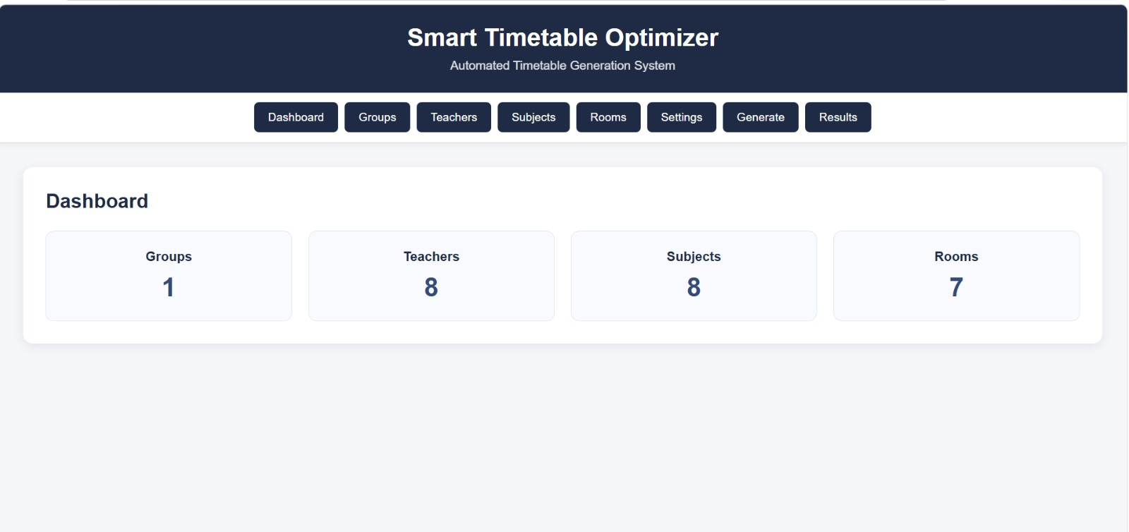
Figure 1.1: Administrator Dashboard of Smart Timetable System
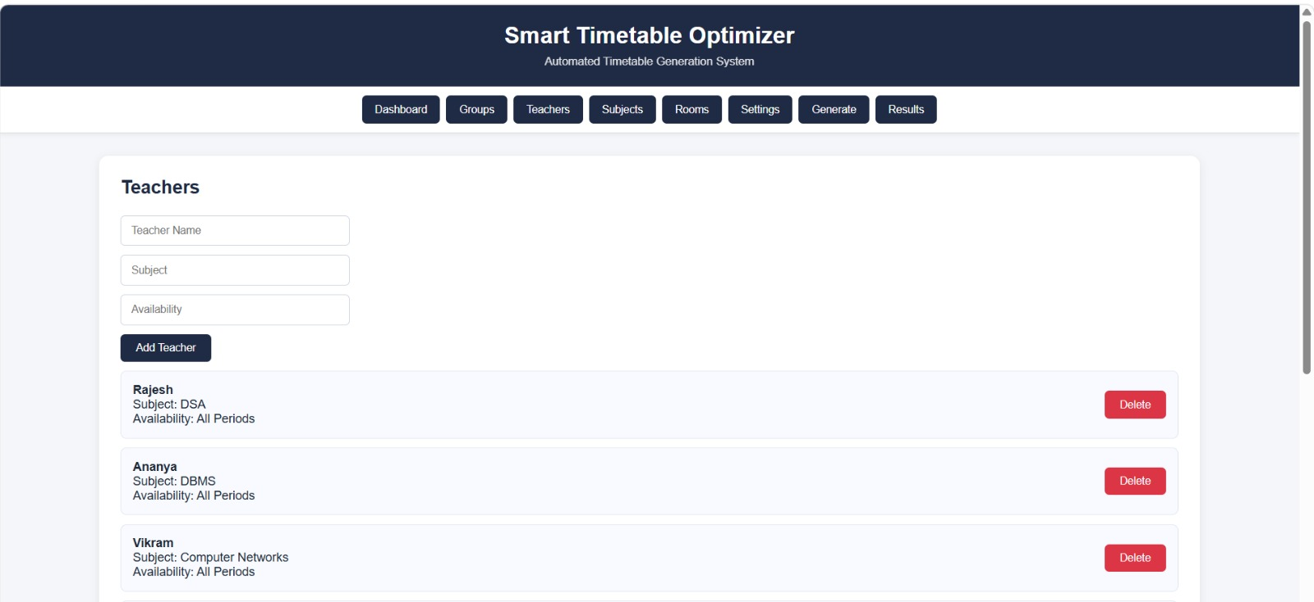

Figure 1.2: Student Group Management Interface

Figure 1.3: Institutional Data Management Interface

CHAPTER 2 – LEARNING OBJECTIVES / INTERNSHIP OBJECTIVES
The primary learning and internship objectives of this Internal Internship (25ISE146) are:

- To gain practical proficiency in C++ programming, focusing on data structures, file handling, and algorithm implementation for constraint satisfaction and optimization.
- To acquire hands-on experience with web technologies (HTML, CSS, JavaScript) for building interactive administrative interfaces.
- To understand the integration of a multi-language stack (Java/JDBC, MySQL, C++, and web front-end) through file-based and database-mediated communication.
- To model a real-world administrative problem (academic timetable generation) as a Constraint Satisfaction Problem and apply classical AI techniques such as backtracking, graph coloring and genetic algorithms.
- To design and implement a usable administrator dashboard that allows data entry, constraint configuration, timetable generation and result visualization.
- To document the complete development process, including system requirements, implementation details, results and lessons learned, in the form of a formal internship report.

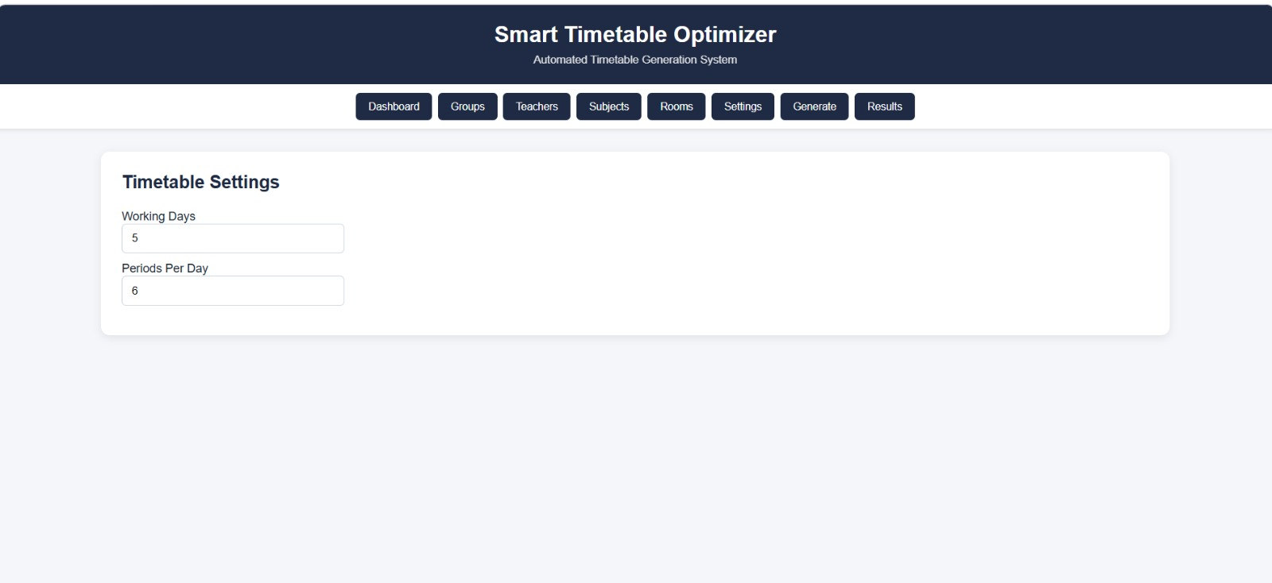
Figure 2.1: Constraint Configuration Interface

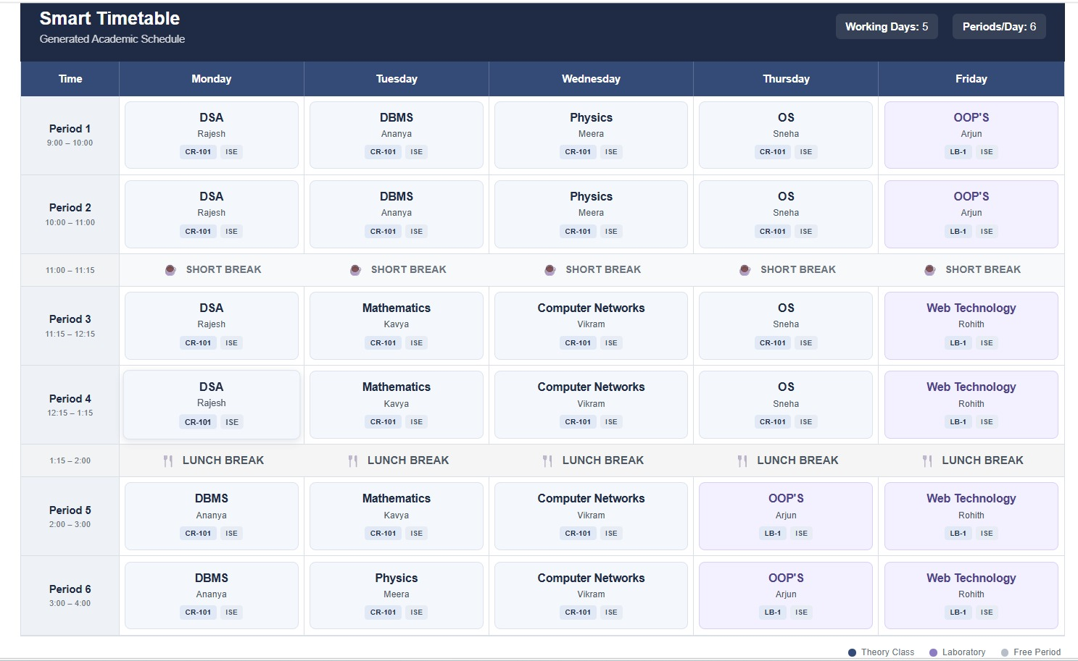
Figure 2.2: Generated Timetable and Optimization Results

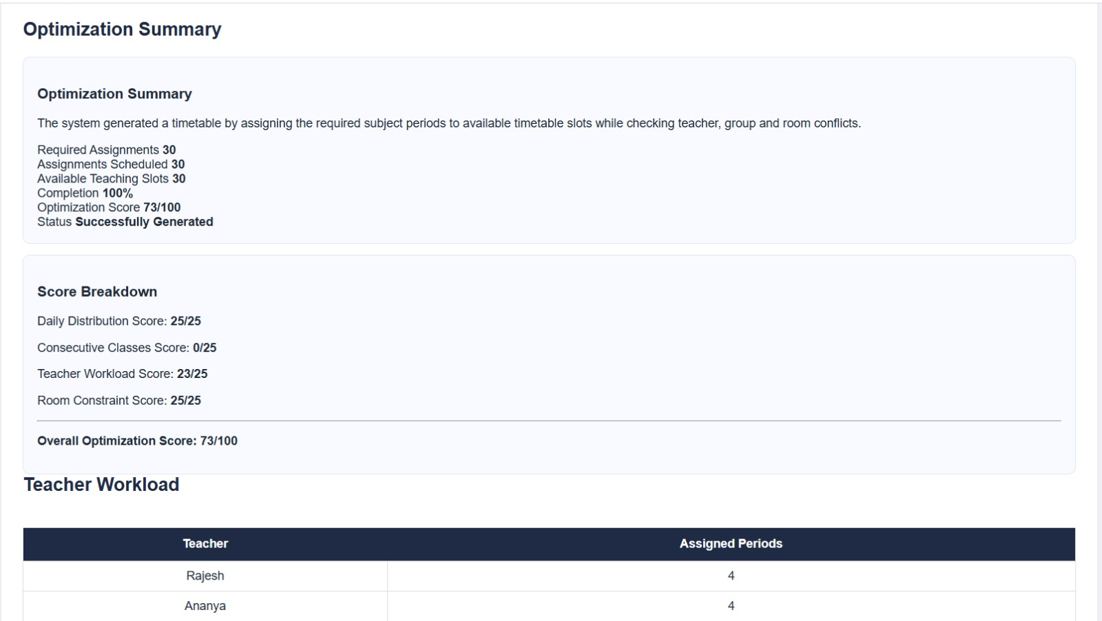

Figure 2.3: Optimization Statistics of Generated Timetable
CHAPTER 3 – WEEKLY OVERVIEW OF INTERNSHIP ACTIVITY
The internship activities were organized week-wise to progressively build the Smart Timetable Possibility & Optimization Engine. A representative overview is given below.
Week 1–2: Requirement Analysis and Environment Setup
Study of existing manual timetable processes; identification of hard and soft constraints; installation of development tools (VS Code, MySQL Server, C++ compiler, Java JDK); creation of the project repository and basic directory structure.
Week 3–4: Data Modelling and Database Design
Design of the relational schema for Groups, Teachers, Subjects and Rooms; implementation of DAO classes in Java; writing JDBC connection and CRUD operations; preparation of sample institutional datasets.
Week 5–6: C++ Optimization Engine – Core Logic
Implementation of input parsing from input.txt; coding of conflict-checking routines (teacher, group, room); development of the graph-coloring seed generator and backtracking search for hard-constraint satisfaction.
Week 7–8: Genetic Algorithm and Scoring
Design of chromosome representation, fitness function (gap minimization, workload balance, preferred slots); implementation of selection, crossover, mutation and steady-state replacement; testing on department-scale data.
Week 9–10: Web Front-end Development
Creation of HTML forms and CSS styling for Student Group Management, Teacher, Subject and Room interfaces; JavaScript for form validation and result display; integration of the generated timetable view on the administrator dashboard.
Week 11–12: Integration, Testing and Documentation
End-to-end integration of front-end → Java/JDBC → MySQL → input.txt → C++ engine → output.txt → result display; constraint-satisfaction and performance testing; preparation of the internship report, screenshots and appendix.

CHAPTER 4 – SYSTEM REQUIREMENT SPECIFICATION
4.1 User Requirements
The system is intended for use by academic administrators and timetable coordinators. The principal user requirements are:
- Ability to enter and manage institutional data — student groups/batches, teachers/faculty, subjects/courses and rooms/laboratories.
- Configuration of working days, periods per day and subject-hour requirements.
- One-click generation of a conflict-free timetable that respects hard constraints (no faculty/room/batch clashes).
- Presentation of the generated timetable together with an optimization score so that the administrator can assess quality.
- Clear diagnostic messages when the supplied constraints are infeasible.
- Export or display of the final schedule for publication and further manual adjustment if required.
4.2 Software Requirements
- Programming Languages: C++ (optimization engine), Java (application & database layer), HTML, CSS and JavaScript (front-end).
- Database: MySQL — stores groups, teachers, subjects and rooms.
- Database Connectivity: JDBC (Java Database Connectivity).
- Data Access Layer: DAO classes (Group DAO, Teacher DAO, Subject DAO, Room DAO).
- File-Based Communication: input.txt (data for C++ engine) and output.txt (generated result).
- IDE: Visual Studio Code.
- Operating System: Windows / Linux.
4.3 Hardware Requirements
- Processor: Intel i5 (or equivalent) or higher.
- RAM: 8 GB minimum (16 GB recommended for large institutional datasets).
- Storage: 5 GB free disk space.

CHAPTER 5 – IMPLEMENTATION AND RESULTS DISCUSSION
5.1 Tasks Executed
The implementation followed a layered architecture that cleanly separates the web front-end, the Java/JDBC data layer, the MySQL database and the C++ optimization engine. The principal tasks executed during the internship are summarized below.
5.1.1 C++
The C++ component constitutes the computational heart of the system. The main implementation tasks were:
- Design of data structures to represent groups, teachers, subjects, rooms and teaching sessions.
- Parsing of institutional data from input.txt prepared by the Java layer.
- Hard-constraint checking: teacher availability and uniqueness, group uniqueness, room uniqueness, capacity and type, and required weekly periods for each subject–batch pair.
- Constructive seeding via a DSATUR-style graph-coloring heuristic to obtain an initial conflict-free timetable.
- Genetic-algorithm improvement phase: tournament selection, constraint-preserving crossover, low-probability mutation, and steady-state replacement driven by a weighted soft-constraint fitness function (gap minimization, workload balance, preferred slots).
- Removal of duplicate solutions and selection of the best-scoring valid timetable, written to output.txt.

Testing on representative department-level datasets confirmed that the engine produces fully conflict-free timetables and that the optimization score improves across generations until a plateau or generation limit is reached.
5.1.2 Web Technology
The web front-end was developed using HTML5, CSS3 and JavaScript. Key implementation tasks included:
- Student Group Management Interface — forms for creating and editing batches.
- Administrator Dashboard providing navigation to all data-entry modules and the generation trigger.
- Institutional Data Management screens for teachers, subjects and rooms.
- Constraint Configuration Interface allowing the administrator to set working days, periods and soft-constraint weights.
- Result Display Module that reads the optimized timetable from the application layer and presents it in a readable grid together with optimization statistics.

The front-end communicates with the Java application, which in turn uses JDBC and DAO classes to persist data in MySQL. When generation is requested, the Java layer prepares input.txt, invokes the C++ engine, reads output.txt and returns the result to the browser for display.

Overall, the integrated system successfully generates valid, optimized timetables and presents them through a clean administrative interface, fulfilling the functional goals of the internship project.

CHAPTER 6 – CONCLUSION
6.1 Overview of Internship Experience
The Internal Internship provided a valuable opportunity to apply classroom knowledge of C++ and web technologies to a concrete, real-world problem. Working on the Smart Timetable Possibility & Optimization Engine deepened understanding of constraint satisfaction, evolutionary algorithms, full-stack integration and the practical challenges of building software that must be usable by non-technical administrators. Collaboration among team members, regular guidance from the faculty mentor, and iterative testing against realistic datasets strengthened both technical skills and professional work habits.
6.2 Challenges Faced
Several challenges were encountered and overcome during the internship:
- Designing a chromosome representation and repair operators that preserve hard constraints during genetic-algorithm crossover and mutation.
- Managing the file-based hand-off between the Java layer and the C++ engine while ensuring data consistency and clear error reporting.
- Balancing soft-constraint weights so that the optimization score produces schedules that are both mathematically good and practically acceptable to faculty.
- Creating an intuitive web interface that remains usable even when the underlying constraint set is complex.

These challenges were addressed through incremental development, systematic debugging, and continuous feedback from the project guide. The resulting system demonstrates that classical AI search techniques combined with a modern web front-end can deliver tangible operational benefits for educational administration.

REFERENCES
1. Constraint Satisfaction Approaches to Timetabling – Survey of CSP formulations, backtracking, forward-checking and arc-consistency techniques for educational scheduling.
2. Genetic Algorithms for University Timetabling – Application of evolutionary and simulated-annealing metaheuristics to large-scale university course scheduling problems.
3. Graph Coloring Models for Scheduling – Modelling of timetabling as graph coloring with DSATUR and greedy heuristics for rapid feasible seed generation.
4. Artificial Intelligence in Educational Administration Systems – Hybrid constructive-plus-metaheuristic pipelines and human-in-the-loop design principles for practical institutional systems.

APPENDIX – I
SUSTAINABLE DEVELOPMENT GOALS
The Smart Timetable Possibility & Optimization Engine aligns with multiple United Nations Sustainable Development Goals (SDGs) by leveraging Artificial Intelligence and optimization techniques to improve educational administration. The project supports SDG 4 (Quality Education), SDG 5 (Gender Equality) and SDG 9 (Industry, Innovation and Infrastructure) by providing a sustainable, efficient and technology-driven platform for academic scheduling.

SDG 4: Quality Education
The system enhances the quality of education delivery by ensuring that academic timetables are generated efficiently, conflict-free and optimized for faculty workload and student convenience. By automating a complex administrative process, it frees up institutional resources that can be redirected towards teaching and learning. Students and faculty benefit from well-balanced schedules that reduce idle gaps and overcrowding, contributing to a more effective learning environment.

SDG 5: Gender Equality
The automated and transparent nature of the timetable generation process helps eliminate unconscious bias that may arise in manual scheduling. Preferred time slots, workload balance and room allocation are handled algorithmically based on objective constraints rather than subjective decisions. This promotes equitable distribution of teaching loads and access to resources for all faculty members irrespective of gender, supporting a fairer academic workplace.

SDG 9: Industry, Innovation and Infrastructure
By integrating classical constraint satisfaction techniques with genetic algorithms and a modern web-based architecture, the project demonstrates how AI-driven innovation can strengthen educational infrastructure. The system provides a scalable, reusable technological solution that institutions can adopt to modernize administrative processes, reduce manual effort and improve operational efficiency — contributing to resilient and innovative institutional infrastructure.

